GOVERNMENT OF INDIA
Ministry of Commerce & Industry | NICDC
Industrial Corridor Project Management System (IC-PMS)

MODULE 8
Resource Management
CPWD SOR / DSR Aligned | Primavera P6 Resource Module Compatible | Labour, Equipment & Material
Detailed Design Document

Document Version: 1.0 | March 2026 | Classification: Restricted
Prepared by: IC-PMS Solution Architect Team | NICDC / Ministry of Commerce & Industry

1. Module Overview

1.1 Purpose & Objectives
Module 8 — Resource Management — is the operational engine that connects physical site resources to the schedule, cost, and contract fabric of IC-PMS. It manages the complete lifecycle of the three fundamental resource categories in construction: Labour (skilled, semi-skilled, unskilled), Equipment (owned, hired, leased), and Material (permanent works, consumables). By providing a unified resource management layer, Module 8 ensures that every scheduled activity in Module 2 has verified resources assigned, every resource cost is captured in Module 4, and every contractor's resource deployment is transparently documented and auditable.
The module is designed for full compatibility with Oracle Primavera P6's resource management model — the industry standard for large construction programme resource management — while being extended with India-specific features: CPWD Schedule of Rates (SOR) and state-specific District Schedule of Rates (DSR) integration for automatic cost loading, state-wise Gazetted holiday calendars, Construction Workers' Welfare Act compliance tracking, and Equipment Log requirements under the Motor Vehicles Act and CMVR.
Resource over-allocation is one of the most common causes of construction schedule slippage — a contractor promises to deploy 20 excavators simultaneously across three packages, discovers they only have 12, and the critical path suffers. Module 8's real-time over-allocation detection and automated levelling tools prevent this by providing a single truth of resource availability and commitment across all packages and contractors within a corridor node.

1.2 Module Scope
Capability | Included | Reference Standard
Resource library (Labour, Equipment, Material) with SOR/DSR rate linkage | Yes | CPWD SOR 2024-25; State DSR; MoRTH Specifications
Resource loading on schedule activities (units, cost, calendar) | Yes | Primavera P6 Resource Assignment model
Labour deployment tracking — daily headcount by skill category | Yes | Construction Workers' Welfare Act / Contract Labour Act
Equipment log — deployment, utilisation hours, breakdown, service | Yes | CMVR / Equipment hire agreement terms
Material issue-and-reconciliation (issued vs. consumed vs. on-site balance) | Yes | CPWD Works Manual — MB-based material accounting
Resource histogram — planned vs. actual vs. capacity (weekly/monthly) | Yes | Primavera P6 Resource Histogram
Resource S-curve — planned vs. actual vs. forecast cost (cumulative) | Yes | EVM / ANSI 748 resource cost S-curve
Over-allocation detection with severity rating | Yes | Primavera P6 Resource Leveling rules
Automated resource levelling (within Total Float) | Yes | Primavera P6 Level Resources algorithm
Manual levelling workbench (drag-and-drop, priority-based) | Yes | P6 Resource Leveling — manual override
Subcontractor resource tracking (sub-letting limit compliance) | Yes | Contract sub-letting clause / GFR guidelines
State-specific holiday calendars (28 states, 8 UTs) | Yes | Gazetted holiday notifications; state Labour Depts.
Resource utilisation KPIs — EDI (Equipment Density Index) | Yes | Module 3 integration — satellite-derived EDI validation
Resource cost integration with Module 4 (ACWP feed) | Yes | Primavera Unifier Cost Manager integration

1.3 Key Design Principles
- Resource-loaded schedules mandatory: No activity in Module 2 can be moved to 'Active' status without at least one resource assignment; this enforces realistic planning and prevents resource conflicts from emerging on site
- SOR-first cost loading: Resource cost rates are pre-loaded from CPWD SOR 2024-25 and state DSRs; the schedule cost (BCWS) is automatically computed from planned resource units × SOR rate — eliminating manual cost entry errors
- Real-time over-allocation visibility: The system checks resource availability every time a new assignment is made and every time a schedule activity date changes; over-allocations are surfaced immediately rather than discovered during site execution
- Primavera P6 compatibility: Resource types, assignment attributes, calendar logic, and levelling algorithms mirror P6's resource management model for seamless data exchange with clients using P6 desktop
- Contractor accountability: Contractors' daily labour returns and equipment logs are entered in IC-PMS (not on paper); this data feeds the contractor performance scorecard in Module 5 and the satellite-derived Equipment Density Index validation in Module 3
- Material reconciliation discipline: Material issued to site must be reconciled against measured quantities in the MB (Measurement Book from Module 4) monthly; unexplained variances above 5% are flagged as potential wastage or theft

2. Sub-Functions — Detailed Requirements

2.1 Sub-Function 8.1 — Resource Library Management
The Resource Library is the master catalogue of all resources available for deployment on IC-PMS projects. Every resource type used on any package — from a mason gang to a 50-tonne tower crane to a batch of OPC cement — is registered here with its code, unit, cost rate, availability profile, and applicable calendar. The library is the foundation from which all resource assignments are drawn.

Resource Type Hierarchy
Resource Type | Unit | Rate Basis | SOR Reference | Key Attributes
Labour — Skilled | Gang / Person | Daily rate; CPWD SOR Table II | CPWD SOR 2024-25 Chapter 3 | Skill category, gang size, OT rate, PF/ESI applicability
Labour — Semi-Skilled | Gang / Person | Daily rate; CPWD SOR Table II | CPWD SOR 2024-25 Chapter 3 | Skill level, trade (bar bender, shuttering carpenter, helper)
Labour — Unskilled | Person | Daily rate; state minimum wage | State Labour Dept. notifications | Gender split tracking for diversity compliance
Equipment — Owned | No. / Hour | Ownership cost = depreciation + maintenance + fuel | CPWD SOR Chapter 6 Plant & Machinery | Make, model, year, registration, insurance, service schedule
Equipment — Hired | No. / Hour / Day | Market hire rate; hire agreement terms | Hire agreement / DSR machinery rates | Hire agency, hire period, standby rate, fuel clause
Material — Permanent Works | MT / M3 / Sqm / RMt / No. | Market rate / SOR; forward rate if available | CPWD SOR; MoRTH Table; IS specifications | Source specification, quality standard, storage instructions
Material — Consumable | Lump Sum | Lump sum per activity; or unit rate | CPWD SOR consumables allowance | Shelf life, storage condition, disposal protocol
Subcontractor | LS / % of LOA | Sub-contract value; % of main contract | Sub-letting clause in NIT | Sub-contractor GSTIN, labour licence, insurance, PF/ESI

Functional Requirements
- Resource code convention: Code format {TYPE}-{CATEGORY}-{SPEC} e.g. LAB-MASON-SK, EQP-EXCAV-20T, MAT-STEEL-TMT — enforced by system; unique across all corridors
- SOR/DSR integration: CPWD SOR 2024-25 rates pre-loaded for all standard resource types; state DSR rates loaded per state where available; market rate override permitted with justification
- Rate escalation: Resources with WPI/CPI-linked escalation clauses automatically updated when RBI publishes monthly indices — escalated rate stored as a dated record alongside the base rate
- Availability profile: Each resource has a maximum availability pool — e.g., 'Excavator 20T: maximum 12 units on this project'; system prevents assignments that exceed the pool
- Calendar assignment: Each resource assigned a working calendar — system uses resource calendar (not activity calendar) to compute available working days and units per period
- Bulk import: Resource library importable from Excel template or Primavera P6 XER resource dictionary — enabling rapid setup for new corridors using existing master data

2.2 Sub-Function 8.2 — Resource Loading & Assignment
Resource Loading is the process of assigning specific resources from the library to scheduled activities — specifying how many units of each resource are needed for each activity and over what time period. A resource-loaded schedule is the basis for all resource histograms, cost budgets (BCWS), and over-allocation analysis.

Assignment Process
- Activity resource requirement entry: From the Module 2 Gantt view or Activity form, the user selects activities and opens the Resource Assignment panel. For each resource needed, the user selects from the Resource Library (search by code or name), enters Planned Units (the total units required for the activity), and selects the Resource Curve (how units are distributed over the activity duration — uniform, front-loaded, back-loaded, or manual profile).
- Rate lookup: On resource assignment, system automatically retrieves the current applicable SOR/DSR rate for the resource. Budgeted Cost = Planned Units × Rate. For labour, cost = Gangs × Gang size × Daily rate × Duration days. For equipment, cost = Units × Hours/day × Hourly rate × Duration days.
- Availability check: System queries the resource availability pool: Available = Pool max − Already committed on overlapping activities. If Requested > Available → over-allocation flag; user warned; assignment can still be saved (with flag) or user can reduce units or change dates.
- Cost computation and Module 4 feed: On saving a resource assignment, the budgeted cost is exported to Module 4 as a line item in the WBS cost ledger (BCWS component). This keeps schedule and cost budget in sync automatically.
- Histogram update: Resource histogram (D11) updated with the new assignment's planned units per week/month for the activity's duration. Over-allocation cells (where total > capacity) highlighted in red.
- S-curve update: Resource cost S-curve (D12) updated with the time-phased planned cost (BCWS) derived from the resource loading — the cumulative cost curve now reflects the new assignment.
- Commitment and notify: Assignment committed to D2 (Resource Assignment store). Module 2 notified of resource loading completion. If this is the last unresourced activity in a WBS package, Module 2 scheduler receives a 'resource-loading complete' flag — enabling baseline submission.
- Bulk assignment: Multiple activities can be selected and a resource loading template applied — useful for repetitive activities (e.g., all foundation pour activities in a package use the same gang and equipment mix).

Resource Curve Types
Curve Type | Profile Shape | Use Case | P6 Equivalent
Uniform (Default) | Equal units per day throughout activity | Most labour and equipment; steady-state activities | Manual — Uniform distribution
Front-loaded | Higher units early; tapering off | Mobilisation-intensive activities; initial earthwork | Bell curve start-heavy
Back-loaded | Low units early; higher units late | Finishing trades; snagging and commissioning | Bell curve end-heavy
Manual Profile | User-defined units per period | Complex equipment or material delivery schedules | Primavera custom curve
Activity-size based | Units proportional to remaining work | EVM integration — reflects % complete | P6 Units/Time resource curve

2.3 Sub-Function 8.3 — Labour Management
Labour Management provides daily, week-by-week tracking of all workers deployed on IC-PMS project sites — capturing headcount by skill category, contractor, and work location. This data feeds the contractor performance scorecard, enables Construction Workers' Welfare Act compliance tracking, and validates the labour component of resource loading.

Functional Requirements
- Daily labour return: Contractor site supervisor submits daily labour return via IC-PMS mobile app or web form — headcount by skill category, contractor name, work location (WBS zone), and shift (day/night)
- Skill categories: Aligned with CPWD SOR and National Skill Qualification Framework (NSQF) — Mason, Bar Bender, Shuttering Carpenter, Plumber, Electrician, Welder, Equipment Operator, Surveyor, Helper (Unskilled), Safety Marshal
- Labour licence compliance: Each labour contractor's Labour Licence (issued under Contract Labour Act) uploaded and tracked — expiry alerts at 60/30/7 days; deployment blocked if licence expired
- PF/ESI compliance: Employee Provident Fund (EPFO) and Employee State Insurance (ESIC) contribution records uploaded monthly; system flags contractors with > 30 days overdue contributions
- Migrant worker registration: For states with migrant worker registration requirements (Building & Other Construction Workers Act), worker registration numbers tracked per contractor
- Daily vs. planned comparison: Each day's reported headcount compared to planned deployment from resource loading; variance > 20% below planned triggers alert to PMC and Module 7 contractor risk update
- Labour productivity index: Actual work output (from MB measurements) ÷ Actual labour deployed = Labour Productivity Index; tracked weekly; declining productivity triggers PMC investigation

2.4 Sub-Function 8.4 — Equipment Tracking & Log
Equipment Tracking maintains a real-time register of every piece of construction equipment on IC-PMS project sites — its deployment location, utilisation hours, breakdowns, service history, and hire costs. This sub-function provides the data backbone for the Equipment Density Index (EDI) that Module 3 validates via satellite imagery.

Equipment Log Data Requirements
Field | Description | Source | Alert Trigger
Equipment ID | Unique IC-PMS code (EQP-TYPE-SEQ) | System assigned on registration | —
Registration / Serial No. | Vehicle registration (for registered equipment) or manufacturer serial number | Contractor documentation | Mismatch with RC book triggers flag
Deployed WBS location | Current WBS package where equipment is deployed | Contractor daily log | Deployment not matching assigned package
Operational hours today | Hours of actual productive operation (from machine hour meter / GPS telematics) | Automated (telematics) or manual entry | 0 hours on a critical path activity date
Cumulative hours this month | Total operational hours from 1st of month | Computed from daily logs | Below 60% of planned monthly hours
Utilisation % | (Actual hours / Available hours) × 100 | Computed | Utilisation > 95% → over-utilised risk; < 50% → under-mobilised
Fuel consumption (L/day) | Daily fuel consumed; crosschecked against machine hour meter | Fuel log from contractor | Fuel consumption > norm for machine type
Breakdown events | Each breakdown: date, duration, cause, repair cost, downtime on critical activity | Contractor + PMC verification | Any breakdown affecting CP activity
Last service date | Date of most recent scheduled preventive maintenance | Contractor maintenance log | Service overdue > 10% of service interval

Functional Requirements
- Equipment registration: All equipment exceeding ₹ 5 Lakh in value or deployed on critical path activities must be registered in Module 8 before deployment; registration includes make, model, year, capacity, RC/insurance details, ownership (owned/hired)
- GPS telematics integration: Where contractors use GPS-enabled telematics (OBD devices on vehicles), the system can integrate via REST API to auto-populate operational hours, location, and idle time — reducing manual data entry burden
- Breakdown management workflow: Contractor logs breakdown → PMC verifies → if on critical path, Module 7 risk trigger auto-generated → replacement equipment requested → downtime tracked in days → delay impact fed to Module 2
- Equipment hire cost tracking: For hired equipment, hire agreement value, daily/monthly rate, fuel clause (inclusive/exclusive), and mobilisation/demobilisation costs tracked; actual hire cost exported to Module 4 as ACWP
- Service schedule management: Preventive maintenance schedule for each equipment unit maintained; upcoming service dates shown in equipment calendar; overdue services flagged with alert to contractor and PMC
- Satellite EDI validation: Module 3's AI-detected Equipment Count per active zone compared against Module 8's registered deployed units; discrepancy > 20% generates reconciliation alert

2.5 Sub-Function 8.5 — Material Management & Reconciliation
Material Management tracks the flow of construction materials from delivery at site gate through issue to work fronts and consumption in the works — providing a complete material reconciliation trail that supports MB-based billing, wastage control, anti-theft monitoring, and environmental compliance (waste disposal tracking).

Material Reconciliation Framework
Stage | Data Captured | Module Link | Alert Condition
Material Delivery | Supplier name, invoice no., vehicle no., material type, quantity delivered, quality test result | Module 5 (Purchase Order) | Quality test failed → block use; raise NCR in Module 6
Material Receipt at Site | Site engineer receipt confirmation, weighbridge slip, storage location assigned | Module 4 (Advance material) | Quantity variance > 2% between invoice and weigh-bridge
Material Issue to Work Front | Issue voucher: WBS activity, date, quantity issued, issued by, received by (foreman) | Module 2 (Activity linkage) | Issue > planned quantity for activity without PMC approval
Material Consumed in Works | MB-certified quantity (from Module 4 Measurement Book) | Module 4 (MB Record) | Issued quantity – Consumed quantity = Site balance; reconcile monthly
On-Site Balance | Physical stock count vs. system balance; monthly joint measurement | Physical stock count | Variance > 5% of issued quantity → investigation
Material Wastage | Wastage = Issued – Consumed – Balance; wastage rate by material type | — | Wastage rate > CPWD norm triggers PMC review
Material Return / Disposal | Surplus material returned to main store or disposed; disposal certificate for hazardous materials | Module 6 DMS (Certificate) | Hazardous material disposal without certificate → compliance flag

Functional Requirements
- Material codes: Aligned with Resource Library (MAT-TYPE-SPEC format); material master linked to SOR rate and IS specification for quality reference
- Batch tracking: For critical materials (structural steel, pre-stressed concrete elements), batch/heat number and test certificate number tracked per delivery; system refuses issue to critical works if test certificate not uploaded
- Quality hold: Materials failing quality tests are placed on 'Hold' status — system prevents issue vouchers for held materials; PMC must clear the hold with a disposition decision (Accept with deviation / Reject and return)
- Monthly reconciliation: System generates material reconciliation statement at month-end: Opening Balance + Delivered – Issued = Closing Balance; reconciled against physical stock count
- Bill of Materials (BOM) integration: Planned consumption from DPR's BoM loaded as target consumption per WBS activity; actual consumption compared against BoM benchmark
- Material at Risk report: Materials with < 7 days' stock at current consumption rate flagged automatically — preventing site stoppage due to material shortage

2.6 Sub-Function 8.6 — Resource Levelling
Resource Levelling resolves over-allocation conflicts — situations where more resources are assigned to activities in a given period than are available in the resource pool. IC-PMS provides both automated levelling (within schedule float) and a manual levelling workbench for complex cases requiring human judgment.

Levelling Algorithms
- Auto-Levelling (Within Total Float): The system identifies all over-allocated periods for each resource. It then delays (pushes forward in time) non-critical activities — those with positive Total Float — to spread resource demand below the capacity ceiling. Critical path activities are never delayed. The levelling algorithm runs in priority order: higher-WBS-priority activities retain resources; lower priority activities are deferred within their float.
- Priority-based Levelling: User assigns a priority (1–10) to each activity or WBS package before levelling. The algorithm respects priorities — even at the cost of using more float on lower-priority activities — to protect strategically important work packages regardless of their float.
- Manual Levelling Workbench: Provides a drag-and-drop histogram interface where the planner can see over-allocated periods as red bars and manually move activity bars to resolve conflicts. The system shows in real time how each move affects the overall resource profile and which activities remain over-allocated.
- Crash Resources: If over-allocation cannot be resolved within float (i.e., it would extend the project end date), the system presents a 'crash resources' option — showing the additional resource cost to bring capacity up to demand. Requires SPV Director approval for costs above threshold.

Levelling Process Steps
- Identify: System scans all resource assignments and flags periods where total assigned units > resource pool capacity. Severity classified: Minor (< 10% over), Moderate (10–25%), Severe (> 25%).
- Analyse: For each over-allocated resource, system shows which activities are contributing to the peak, how much float each contributing activity has, and what the peak percentage is.
- Select strategy: User selects Automatic (within float), Priority-based, Manual, or Crash Resources. For Automatic: user sets the float consumption limit (e.g., 'use up to 5 days of float for levelling').
- Preview impact: System shows Before/After histogram comparison; lists all activities that will be rescheduled, their new dates, and float consumed. No schedule changes made until user approves.
- Approve and apply: User reviews preview and approves. Schedule changes applied in Module 2; resource assignments updated. SPV PM digital approval required if > 5 CP activities affected.
- Post-levelling check: System re-runs CPM and re-checks all resources. If residual over-allocations exist, repeats process. Levelling plan saved in D6 for audit trail.

2.7 Sub-Function 8.7 — Subcontractor Resource Tracking
Subcontractor tracking ensures that the main contractor's sub-letting activity is within the contractual and GFR-mandated limits, that all subcontractors are registered with NICDC, and that their resource deployments are visible in the Module 8 resource plan — preventing the situation where a subcontractor's workforce is 'invisible' to the project monitoring system.

Functional Requirements
- Subcontractor registration: Every subcontractor engaged by the main EPC contractor must be registered in Module 8 with: Company name, GSTIN, Labour licence number, Insurance details, Scope of work, Sub-contract value, Sub-letting percentage of main LOA
- Sub-letting limit monitoring: System tracks cumulative sub-contracted value as % of main LOA (GFR limit: 49% without explicit NICDC approval); alert at 40%; workflow triggered at 49%
- Subcontractor resource loading: Subcontractor's labour and equipment entered in Module 8 as a sub-set of the main contractor's resource pool; subcontractor resources visible in the same histogram as main contractor resources
- Subcontractor performance: Subcontractor-level performance metrics (productivity, safety incidents, quality NCRs) tracked separately and rolled up to the main contractor's Module 5 performance scorecard
- Payment visibility: Subcontractor payment by main contractor tracked (main contractor certifies sub-payment); system alerts if main contractor has received payment from SPV but subcontractor payment is > 30 days overdue — protecting sub-contractor payment rights

2.8 Sub-Function 8.8 — Resource Reporting
Resource Reporting generates all standard resource performance reports required by NICDC governance, Ministry oversight, and Module 9's executive dashboard — drawing on the Labour Log, Equipment Log, Material Records, Histogram, and S-Curve data stores.

Standard Resource Reports
Report | Frequency | Audience | Key Content
Monthly Resource Report (MRR) | Monthly — 5th of month | NICDC / SPV Director / PMC | Labour headcount planned vs. actual by category; equipment utilisation by type; material consumption vs. plan; over-allocation summary; EDI comparison with Module 3 satellite
Weekly Labour Flash | Weekly — Monday | PMC / SPV PM | Daily average headcount last week; skill category breakdown; contractors below planned deployment; labour productivity index trend
Equipment Utilisation Report | Monthly | PMC / SPV Operations | Per-equipment utilisation %; breakdown history and downtime; hire cost actuals vs. budget; equipment at risk (low utilisation on CP activities)
Material Reconciliation Statement | Monthly — last day | SPV Finance / PMC QA | Material-wise: opening balance, delivered, issued, consumed (MB), closing balance, wastage %, variance flag
Resource S-Curve Report | Monthly with MRR | NICDC Finance / Module 9 | Cumulative planned vs. actual resource cost S-curve by resource type and WBS scope
Over-Allocation Report | Weekly (auto) | PMC Planner / SPV PM | All over-allocated resources this week; severity; affected activities; recommended levelling actions
Subcontractor Resource Register | Monthly | NICDC / SPV Legal | All subcontractors with resource deployment, sub-letting %, payment status, compliance certificate status

3. Data Flow Diagrams

3.1 DFD Level 0 — Context Diagram
The Context Diagram shows Module 8 as the Resource Management Engine (Process 8.0) receiving activity resource requirements from Module 2, budget rates from Module 4, contract resource terms from Module 5, SOR/DSR reference rates from CPWD/State, and daily labour/equipment logs from contractors. It outputs resource cost to Module 4, utilisation data to Module 9, and levelling decisions back to Module 2.
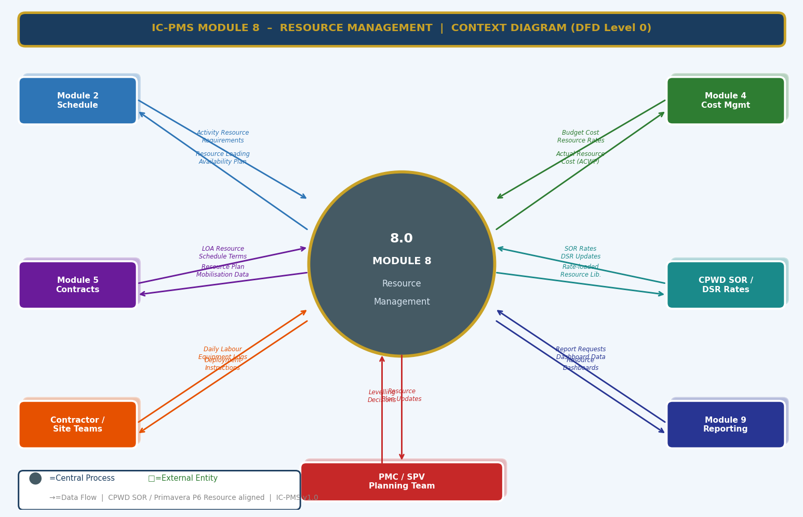
Figure 3.1 — DFD Level 0: Module 8 Context Diagram (Schedule, Cost, Contract, SOR, Field Inputs; Resource Outputs)

External Entity Data Flow Summary
External Entity | Inputs to Module 8 | Outputs from Module 8
Module 2 — Schedule | Activity list with resource requirements, activity durations and dates, CPM float data for levelling | Resource loading confirmation (BCWS), levelling-adjusted schedule dates, over-allocation flags
Module 4 — Cost Management | Budget cost rates for resource cost validation; ACWP feed confirmation | Actual resource costs (ACWP) per WBS activity; resource-derived budget (BCWS) by cost category
Module 5 — Contract Management | LOA resource schedule terms, approved subcontractors list, resource deployment obligations | Contractor resource deployment actuals vs. LOA commitment; subcontractor register; labour compliance data
CPWD SOR / DSR | Current SOR 2024-25 rate tables for labour, equipment, material; state DSR variants | Rate-loaded resource library entries; escalated rates with WPI/CPI adjustments
Contractor / Field Teams | Daily labour returns (headcount by skill); equipment operational logs; material delivery and issue records | Resource deployment instructions; planned vs. actual comparison; compliance alerts
Module 9 — Reporting | Report generation requests; dashboard data queries | Monthly Resource Reports; Labour/Equipment dashboards; Material reconciliation; Resource S-curves
PMC / SPV Planning Team | Levelling strategy decisions; priority assignments; manual adjustment approvals | Levelling plan with Before/After comparison; impact summary; schedule change request to Module 2

3.2 DFD Level 1 — Main Processes & Data Stores
The Level 1 DFD shows eight core resource management processes and eight data stores spanning the complete resource lifecycle from library management through loading, tracking, levelling, and reporting.
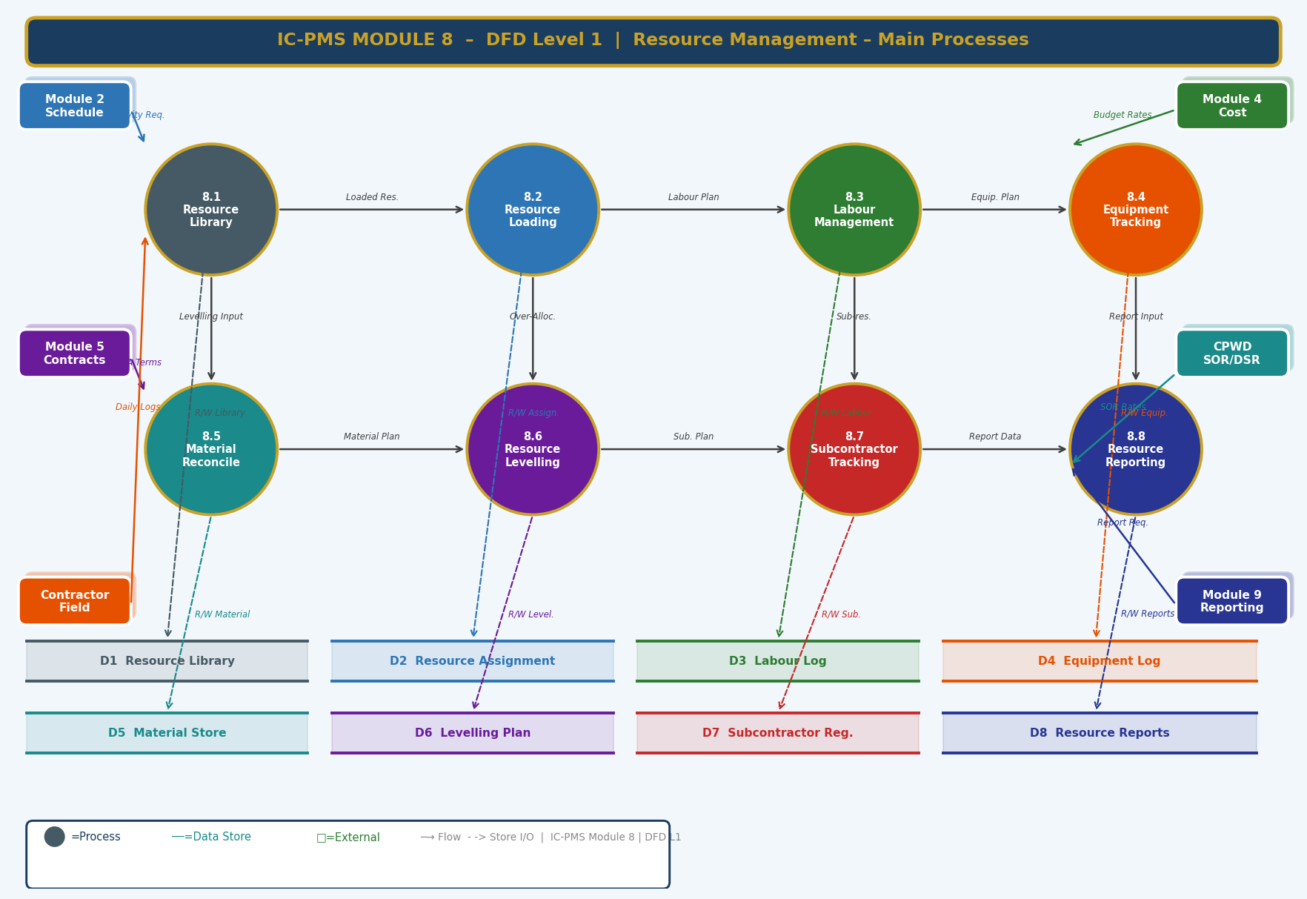
Figure 3.2 — DFD Level 1: Eight Core Processes and Eight Data Stores

Process and Data Store Descriptions
ID | Name | Function | Key Stores
8.1 | Resource Library | Maintains master resource catalogue with codes, rates, availability, calendars; SOR/DSR rate sync | D1 Resource Library
8.2 | Resource Loading | Assigns resources to activities; computes BCWS; detects over-allocation; updates histogram and S-curve | D2 Resource Assignment, D11 Histogram, D12 S-Curve
8.3 | Labour Management | Tracks daily headcount by skill; monitors labour licence and PF/ESI compliance; computes productivity index | D3 Labour Log
8.4 | Equipment Tracking | Maintains equipment log; tracks utilisation, breakdowns, service; GPS telematics integration | D4 Equipment Log
8.5 | Material Reconciliation | Tracks material delivery, issue, consumption, balance; generates monthly reconciliation; quality hold management | D5 Material Store
8.6 | Resource Levelling | Detects and resolves over-allocation; auto-level, priority-level, manual workbench, crash options | D6 Levelling Plan
8.7 | Subcontractor Tracking | Monitors sub-letting %; tracks subcontractor resources; compliance and payment tracking | D7 Subcontractor Reg.
8.8 | Resource Reporting | Auto-generates MRR, Labour Flash, Equipment Utilisation, Material Reconciliation, S-Curve reports | D8 Resource Reports

3.3 DFD Level 2 — Process 8.2: Resource Loading & Assignment (Exploded)
The Level 2 DFD drills into the Resource Loading & Assignment process — the core operational workflow that connects resources to scheduled activities. It shows all eight sub-processes from activity resource pull through rate lookup, availability check (decision diamond), cost computation, histogram generation, S-curve update, and final commitment with notifications.
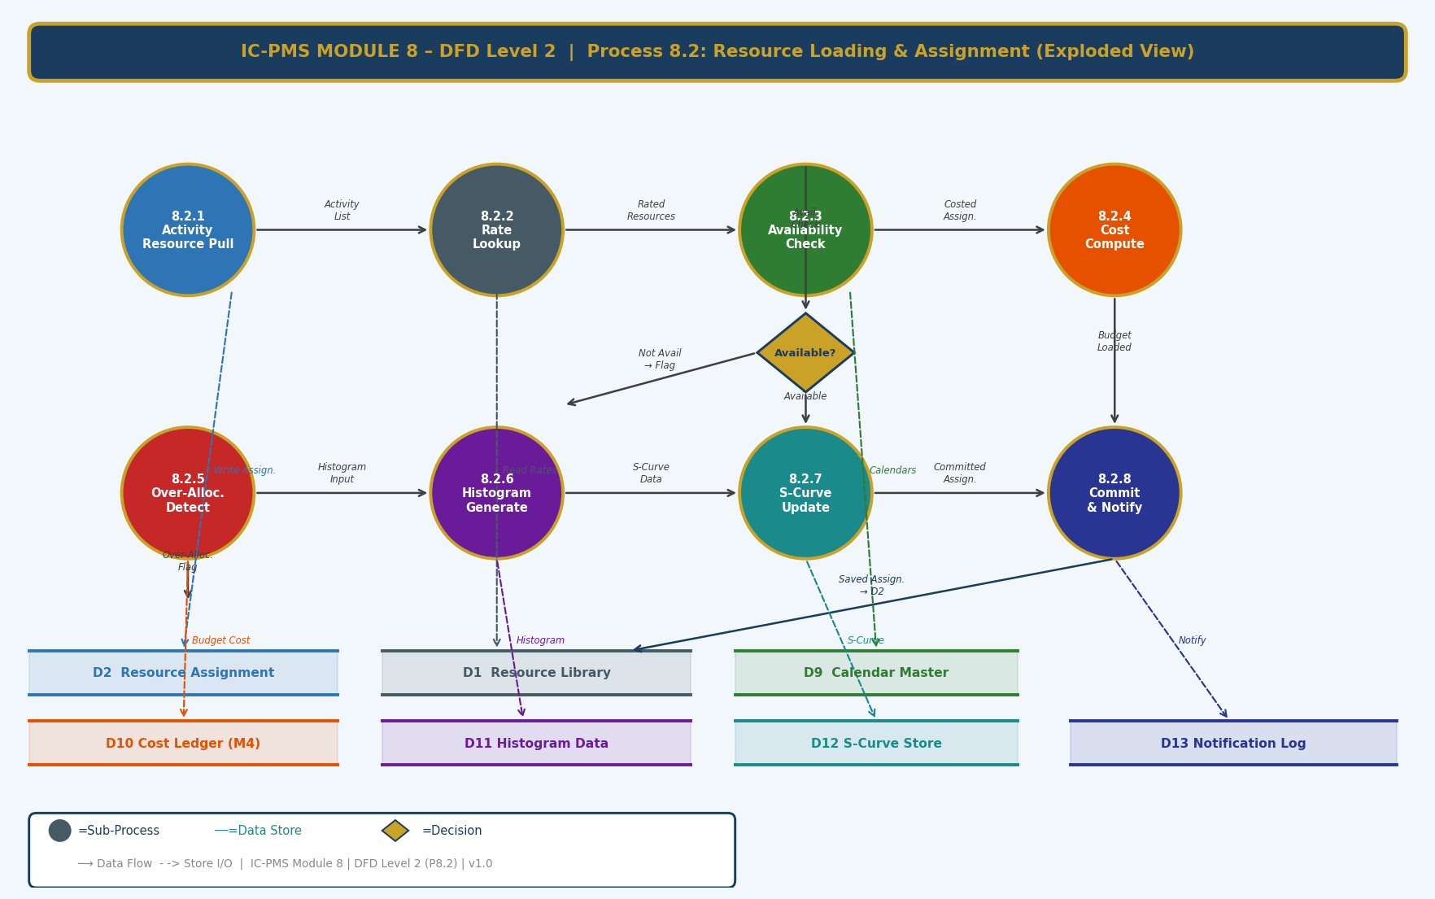
Figure 3.3 — DFD Level 2: Process 8.2 Resource Loading — 8 Sub-Processes with Availability Decision Diamond

Sub-Process Narrative
Sub-Process | Name | Description
8.2.1 | Activity Resource Pull | Reads all activities from Module 2 that require resource assignment (status: Needs_Resource). For each activity, reads the standard resource template from D1 (Resource Library) if a template exists for that activity type/discipline. Pre-populates the resource assignment form with suggested resources.
8.2.2 | Rate Lookup | For each resource to be assigned, queries D1 (Resource Library) for the current applicable rate. Rate selection logic: (1) Check project-specific negotiated rate; (2) Check corridor-level rate agreement; (3) Fall back to CPWD SOR 2024-25 base rate. Escalated rate applied if assignment date is beyond the SOR base year.
8.2.3 | Availability Check | Queries D2 (Resource Assignment) for all existing assignments of this resource over the activity's date range. Computes: Available = Pool_Max − Sum(already_committed). If Available ≥ Requested: proceed to cost compute. If Available < Requested: over-allocation flag; user warned with severity level; assignment can proceed with flag (decision diamond routes accordingly).
8.2.4 | Cost Computation | Computes Budgeted Cost = Planned_Units × Rate × Duration. For time-phased cost, applies the resource curve to distribute the total cost over the activity duration. Exports budgeted cost to D10 (Cost Ledger in Module 4) as a new BCWS line item. Ensures WBS cost budget is updated.
8.2.5 | Over-Allocation Detection | Aggregates all resource assignments per period to identify over-allocated periods. Classifies severity: Minor (< 10% over capacity), Moderate (10–25%), Severe (> 25%). Populates over-allocation flags in D2. Generates alert records for PMC planner and Module 7 (contractor risk).
8.2.6 | Histogram Generation | Updates D11 (Histogram Data) with planned units per week for this assignment. Regenerates the resource histogram chart data for this resource across all assignments. Marks over-allocated periods in red (> capacity), warning in amber (> 90% capacity), normal in green.
8.2.7 | S-Curve Update | Updates D12 (S-Curve Store) with the time-phased budgeted cost from this assignment. Recomputes the cumulative planned resource cost (BCWS) curve from earliest activity start to latest finish. Also updates the forecast curve based on current earned value and remaining resource loading.
8.2.8 | Commit & Notify | Saves the final resource assignment record to D2 with all computed values. Sends notification to the activity's responsible contractor if this is the first resource assignment for their activity. Notifies Module 2 scheduler if all activities in a WBS package are now resource-loaded (baseline submission trigger). Logs assignment event in audit trail.

4. Master Data Model

4.1 Entity Relationship Overview
The Module 8 master data model contains twelve entities. The Resource Library is the master reference entity; Resource Assignment is the operational link between library resources and schedule activities; Labour Log, Equipment Log, and Material Record are the daily tracking entities. Levelling Plan, Subcontractor Register, Histogram Record, and Resource S-Curve are the analytical output entities. Calendar Master and Skill Category are configuration entities. Equipment Breakdown is a detail entity under Equipment Log.
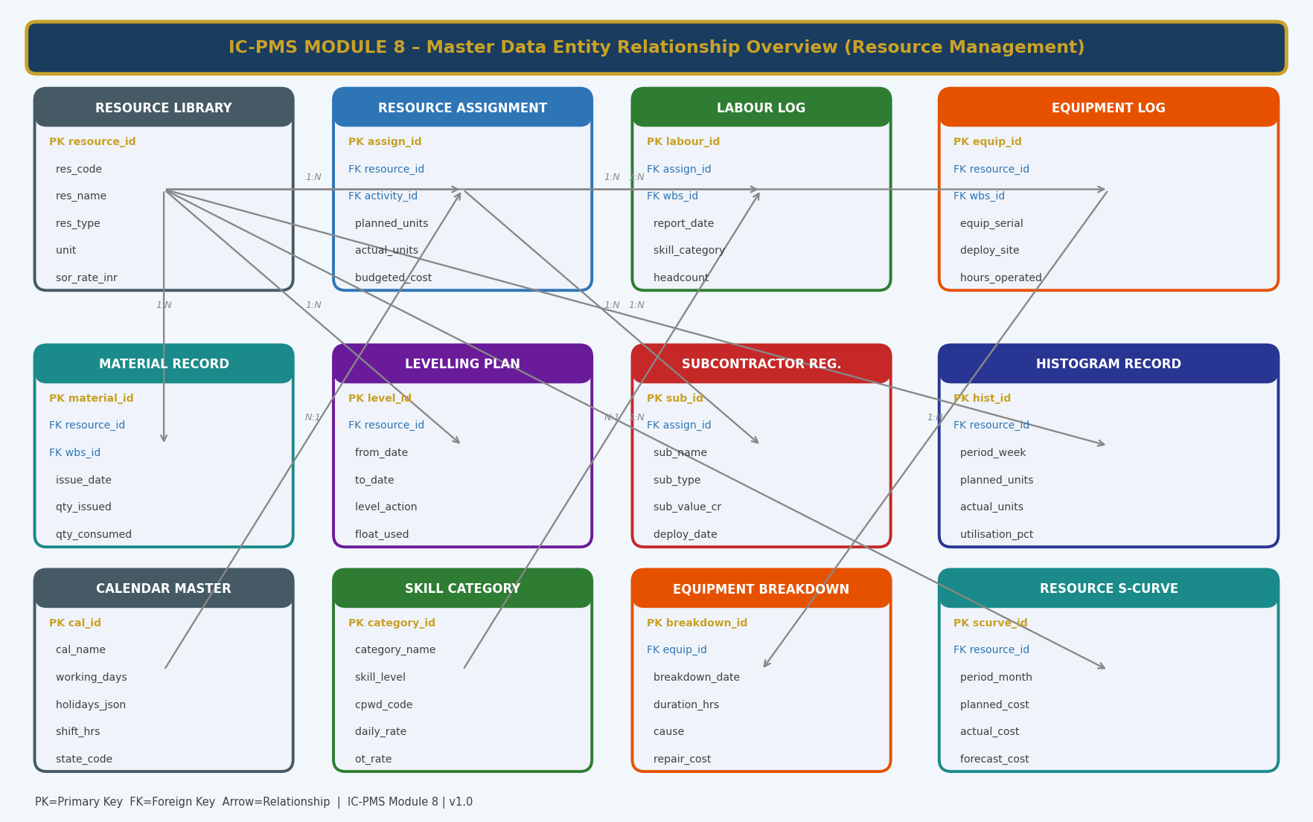
Figure 4.1 — Master Data Entity Relationship Overview (Module 8 — Resource Management)

4.2 Core Entity Field Definitions

4.2.1 Resource Library
resource_id | UUID — Primary Key
res_code | VARCHAR — unique code: {TYPE}-{CATEGORY}-{SPEC} e.g. EQP-EXCAV-20T
res_name | VARCHAR — descriptive resource name
res_type | ENUM: Labour_Skilled / Labour_Semi / Labour_Unskilled / Equipment_Owned / Equipment_Hired / Material_Permanent / Material_Consumable / Subcontractor
unit | VARCHAR — Gang / Person / No. / MT / M3 / Sqm / RMt / LS / Hour
sor_rate_inr | DECIMAL(12,2) — CPWD SOR 2024-25 base rate in INR per unit
sor_reference | VARCHAR — SOR item number for rate justification and audit
market_rate_inr | DECIMAL(12,2) — current market rate if differs from SOR (with justification)
effective_rate_inr | DECIMAL(12,2) — computed: apply WPI escalation to sor_rate for current period
max_availability | DECIMAL — maximum units available project-wide (pool ceiling for levelling)
calendar_id | FK → Calendar Master — resource-specific working calendar
skill_category_id | FK → Skill Category — for labour resources only
ot_rate_multiplier | DECIMAL(3,2) — overtime rate multiplier (typically 1.5×); applies beyond standard hours
state_code | VARCHAR — if rate varies by state (state-specific DSR items)
res_status | ENUM: Active / Suspended / Retired

4.2.2 Resource Assignment
assign_id | UUID — Primary Key
resource_id | FK → Resource Library
activity_id | FK → Module 2 Activity (schedule activity being resourced)
wbs_id | FK → Module 1 WBS Element — for direct WBS-level resource planning
planned_units | DECIMAL — total planned units of resource for this activity
units_per_timeperiod | DECIMAL — rate per day/week (calculated from planned_units and duration)
resource_curve | ENUM: Uniform / Front_Loaded / Back_Loaded / Manual
budgeted_cost_inr | DECIMAL(15,2) — computed: planned_units × effective_rate
actual_units | DECIMAL — actual units consumed to date (from labour/equipment logs)
actual_cost_inr | DECIMAL(15,2) — actual cost to date (exported to Module 4 ACWP)
remaining_units | DECIMAL — computed: planned_units − actual_units
over_allocation_flag | BOOLEAN — true if this assignment contributes to an over-allocation period
over_allocation_severity | ENUM: None / Minor / Moderate / Severe
assignment_status | ENUM: Draft / Committed / Partially_Complete / Complete
contractor_id | FK → Organisation Master — the contractor responsible for providing this resource

4.2.3 Labour Log
labour_id | UUID — Primary Key
assign_id | FK → Resource Assignment — the labour resource assignment this log records against
wbs_id | FK → WBS Element — work location
report_date | DATE — the date of this daily labour return
skill_category_id | FK → Skill Category — mason, bar bender, etc.
contractor_id | FK → Organisation Master — the contractor reporting this labour
headcount | INTEGER — number of workers deployed this day in this skill category
shift | ENUM: Day / Night / Both
work_location | VARCHAR — specific grid/zone within WBS where labour deployed
labour_licence_no | VARCHAR — contract labour act licence number
labour_licence_expiry | DATE — expiry of contract labour licence
pf_esic_current | BOOLEAN — true if PF/ESI contributions are current (≤ 30 days arrear)
productivity_note | TEXT — optional PMC note on labour productivity or issues
verified_by | FK → User — PMC engineer who verified the daily return

4.2.4 Equipment Log
equip_id | UUID — Primary Key
resource_id | FK → Resource Library — the equipment type
wbs_id | FK → WBS Element — deployed location
equip_serial | VARCHAR — machine serial number or vehicle registration
deploy_date | DATE — date equipment was mobilised to site
deploy_site | VARCHAR — specific work front or zone
ownership_type | ENUM: Owned / Hired / Leased
hire_agency | VARCHAR — if hired: name of hire agency
hire_rate_inr_per_day | DECIMAL(12,2) — daily hire rate if applicable
hours_operated_today | DECIMAL(5,2) — operational hours today (from log or telematics)
cumulative_hours_month | DECIMAL(7,2) — total operational hours this calendar month
utilisation_pct | DECIMAL(5,2) — computed: (actual hrs / available hrs) × 100
fuel_consumption_lpd | DECIMAL(6,2) — litres per day if fuel tracked
last_service_date | DATE — date of last scheduled preventive maintenance
next_service_due | DATE — computed from service interval
telematics_device_id | VARCHAR — GPS/OBD telematics device ID if integrated
equip_status | ENUM: Operational / Stand_by / Breakdown / Under_Service / Demobilised

4.2.5 Material Record
material_id | UUID — Primary Key
resource_id | FK → Resource Library — the material type
wbs_id | FK → WBS Element — the work package this material is for
delivery_date | DATE — date of delivery to site
supplier_name | VARCHAR
supplier_invoice_no | VARCHAR — supplier's delivery invoice number
qty_delivered | DECIMAL — quantity as per delivery note
qty_weigh_bridge | DECIMAL — quantity as per weigh-bridge (if applicable)
quality_test_status | ENUM: Pending / Passed / Failed / Waived
test_certificate_doc_id | FK → Module 6 DMS — quality test certificate document
hold_status | BOOLEAN — true if material is on quality hold (cannot be issued)
issue_date | DATE — date material was issued to work front
qty_issued | DECIMAL — quantity issued from store to work front
qty_consumed_mb | DECIMAL — quantity certified in Measurement Book (from Module 4)
qty_on_site_balance | DECIMAL — computed: qty_delivered − qty_issued
wastage_qty | DECIMAL — computed: qty_issued − qty_consumed_mb
wastage_pct | DECIMAL(5,2) — wastage as % of issued quantity; > CPWD norm triggers alert

4.2.6 Equipment Breakdown
breakdown_id | UUID — Primary Key
equip_id | FK → Equipment Log
breakdown_date | TIMESTAMP — exact date and time breakdown occurred
breakdown_duration_hrs | DECIMAL — total downtime in hours (running total until repair)
cause | TEXT — technical description of failure cause
on_cp_activity | BOOLEAN — true if the equipment was on a critical path activity when breakdown occurred
repair_cost_inr | DECIMAL(12,2) — cost of repair parts and labour
spare_part_ordered | BOOLEAN — true if spare parts have been ordered
replacement_requested | BOOLEAN — true if PMC has requested a replacement unit
impact_on_schedule | VARCHAR — description of schedule impact (e.g. 'A046 Formwork: +3 day delay')
pmc_verified | BOOLEAN — true if PMC has physically verified the breakdown
repaired_date | DATE — date equipment returned to operational status
risk_trigger_raised | BOOLEAN — if CP impact: true if Module 7 risk trigger was auto-generated

5. UI/UX Screen Designs
Module 8 delivers five primary screens covering the main resource management workflows. The module uses steel blue (#455A64) as its identity colour — evoking construction machinery and the practical, operational nature of resource management. The screens are designed for two primary user profiles: PMC Planners (who need detailed histogram and levelling views) and Site Engineers / Contractors (who need simple, mobile-friendly forms for daily labour and equipment logs). The desktop screens prioritise data density; the mobile companion views (accessible from the same URL on phones) prioritise simplicity.

Screen 1 — Resource Management Dashboard
The Dashboard provides an instant operational status of all resources across the programme — labour deployed vs. plan, equipment utilisation by type, material reconciliation summary, and over-allocation count. It is the Monday morning first-look screen for PMC resource managers and SPV operations staff.
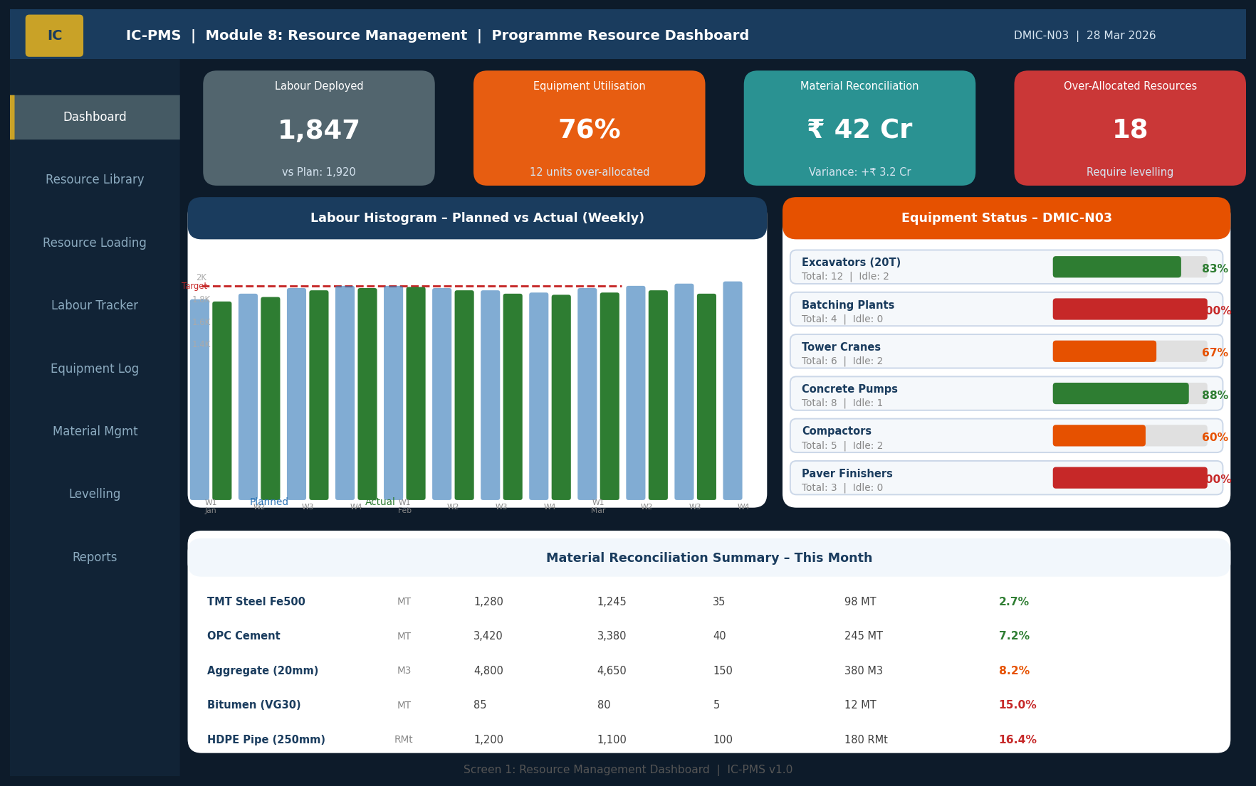
Figure 5.1 — Resource Dashboard (Labour Histogram KPIs, Equipment Utilisation Panel, Material Reconciliation, Over-Allocation Alerts)

Dashboard UI Components
Component | Description | Interaction
KPI Cards (4 — top row) | Labour Deployed (vs. plan), Equipment Utilisation %, Material Reconciliation Value (variance), Over-Allocated Resources count. Colour-coded orange/red for variance. | Click any card to navigate to the detailed screen for that resource type
Labour Histogram (left) | Weekly grouped bar chart: Planned (blue) vs. Actual (green). Capacity line in red dashed. Over-target weeks shown with red bars. | Hover for exact weekly counts; click a week bar to see day-by-day breakdown
Equipment Status Panel (right) | Per equipment type: total units, deployed, utilisation % bar. Red bar = over-utilised (> 95%), orange = high (85–95%), green = normal. | Click equipment row to open Equipment Log (Screen 4) filtered to that type
Material Reconciliation (bottom) | Per material type: Issued, Consumed (MB), Variance, On-Site, Wastage %. Red/orange/green coded by wastage vs. CPWD norm. | Click material row to open Material Management detail view

Screen 2 — Resource Library
The Resource Library screen is the master data management interface — a searchable, filterable table of all registered resources with rates, availability, and calendar assignments. It is the starting point for resource setup and the reference point for all cost loading queries.
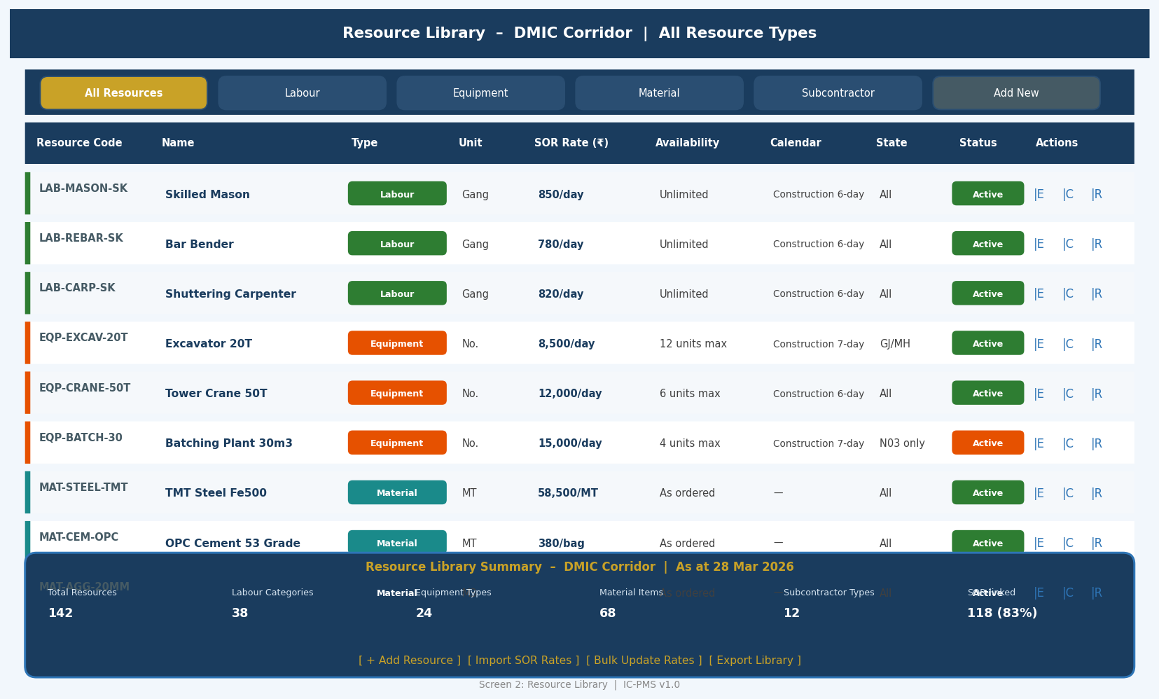
Figure 5.2 — Resource Library (Type Filter Tabs, Rate Table, SOR Reference, Availability, Status)

Resource Library Screen Design
- Type filter tabs: Six tabs (All / Labour / Equipment / Material / Subcontractor / Add New) with count badges; single-click to view just that resource type category
- Coloured left stripe: Each row has a stripe colour matching the resource type (green = Labour, orange = Equipment, teal = Material, purple = Subcontractor) — instant type recognition without reading the Type column
- Rate column: Current effective rate shown in bold (SOR base + WPI escalation if applicable); clicking the rate opens a rate history popup showing all historical rates and the WPI adjustment calculation
- Availability column: Shows the pool ceiling (e.g., '12 units max' for Excavators); clicking shows a calendar view of committed vs. available units for the next 3 months
- SOR reference: Each resource links to its CPWD SOR item number — clicking opens the SOR clause in a reference panel for PMC engineers to verify rate justification
- Import SOR Rates button: Bulk re-loads all rates from the latest CPWD SOR file (Excel upload); system computes WPI-adjusted effective rates automatically

Screen 3 — Resource Histogram & Loading
The Histogram screen is the primary planning workbench for resource managers — showing the weekly planned vs. actual vs. capacity histogram, the cumulative cost S-curve, and the per-activity resource assignment table in a single integrated view. Over-allocated periods are immediately visible as red bars.
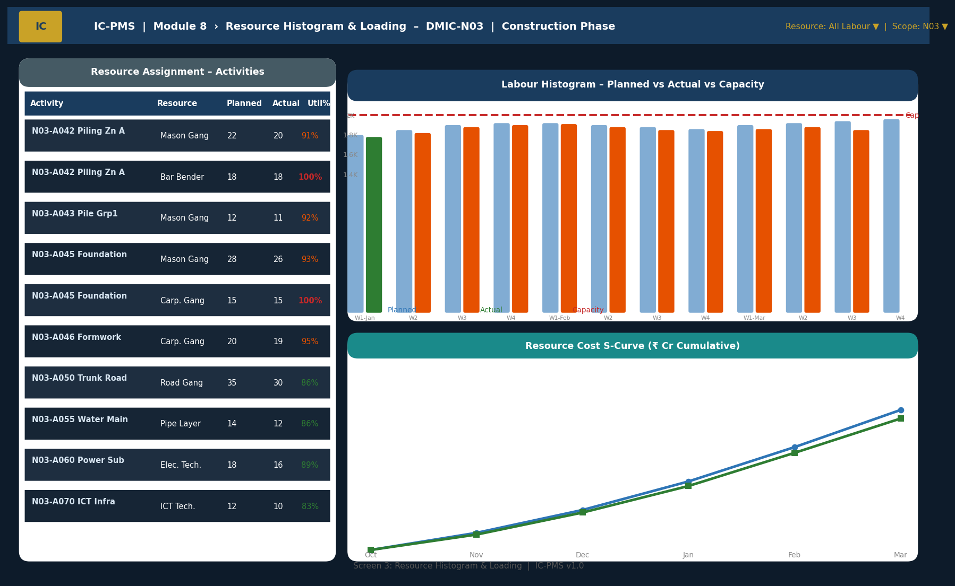
Figure 5.3 — Resource Histogram (Activity Assignment Table, Labour Histogram with Capacity Line, Resource Cost S-Curve)

Histogram Screen Design Decisions
- Three-panel layout: Left = activity-resource assignment table (what is assigned to what); Centre-top = histogram (are we over or under capacity?); Centre-bottom = cost S-curve (are we spending as planned?)
- Capacity line: Red dashed horizontal line at 100% capacity — the most important visual element; any bar above this line is a problem requiring attention
- Dual bar per week: Two bars per week column — blue (planned, semi-transparent) and solid coloured (actual) — enable instant planned vs. actual comparison without switching views
- Actual bar colour semantics: Green (< 90% capacity), Orange (90–99%), Red (100% = at capacity), Dark Red (> 100% = over-allocated) — colour changes without the user needing to read numbers
- 100% utilisation highlight: Rows in the assignment table where utilisation = 100% are highlighted in red — immediately visible to the planner
- S-curve variance shading: Orange shaded band between planned and actual cumulative cost lines — visible cost performance variance without reading numbers

Screen 4 — Equipment Log & Tracker
The Equipment Log screen provides a complete register of all equipment on site — deployment status, daily operational hours, utilisation, breakdown history, and service schedule. It is the screen used by PMC engineers to monitor contractor equipment mobilisation and identify underperforming or at-risk equipment.
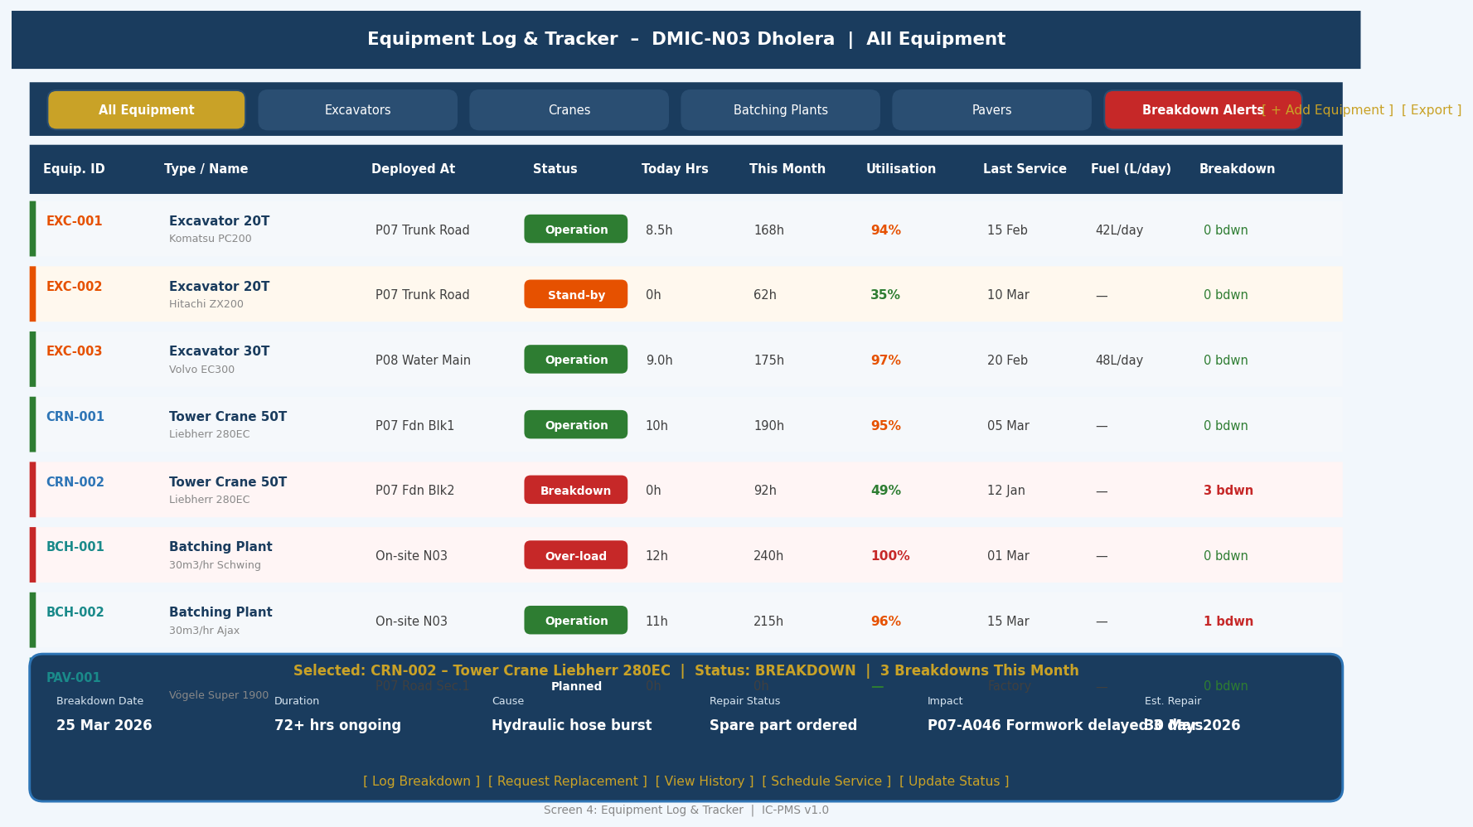
Figure 5.4 — Equipment Log (Status-coded Rows, Utilisation Bars, Breakdown Detail Panel, Service Alerts)

Equipment Log Screen Design
- Status left stripe: Coloured left stripe per row — Green (Operational), Orange (Stand-by), Red (Breakdown / Over-loaded), Teal (Planned / Not yet mobilised)
- Utilisation column: Colour-coded percentage — red if at/above 95% (over-utilised risk), orange for 85–95% (high utilisation), green for normal range
- Breakdown count badge: Number of breakdowns this month shown in the last column — 0 = green text, 1–2 = orange, > 2 = red and bold — immediately flags problematic equipment
- Filter tabs: Six tabs by equipment type (Excavators, Cranes, Batching Plants, Pavers, Breakdown Alerts) — 'Breakdown Alerts' tab aggregates all equipment currently in breakdown across all types
- Detail panel: Fixed at bottom; loads on row click; shows breakdown cause, repair status, impact on schedule, and action buttons (Log Breakdown, Request Replacement, Schedule Service)
- Service due alerts: Equipment approaching service date shown with amber highlight in 'Last Service' column; overdue service shown in red

Screen 5 — Resource Levelling Workbench
The Levelling Workbench is the most technically complex screen in Module 8 — a three-panel interface combining the over-allocation list, the Before/After histogram comparison, and the levelling strategy selector and impact summary. It is designed for experienced PMC planners who need to understand and approve the implications of levelling decisions.
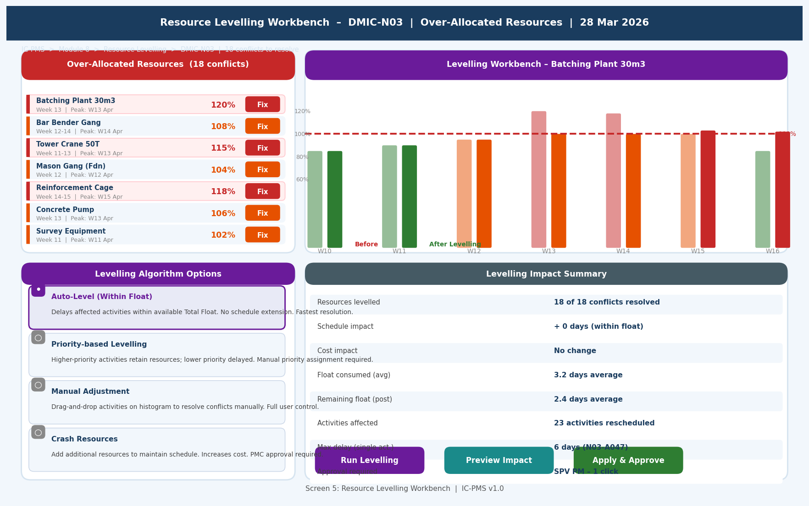
Figure 5.5 — Resource Levelling Workbench (Over-Allocation Panel, Before/After Histogram, Strategy Options, Impact Summary)

Levelling Workbench Design Principles
- Three-panel layout: Left = what needs fixing (over-allocation list); Centre = histogram before vs. after (visual impact of levelling); Right = how to fix it (strategy options) + what the cost is (impact summary)
- Before/After histogram: Two sets of coloured bars per week — semi-transparent for 'Before', solid for 'After Levelling' — makes the improvement immediately visible; red bars (over capacity) should disappear in the 'After' view
- Radio button strategy selector: Four clearly described options with trade-offs explained — users with different priorities (schedule vs. cost) can select the most appropriate approach
- Impact summary before committing: 'Run Levelling' shows the impact summary (schedule changes, float consumed, activities affected) as a PREVIEW — user must explicitly click 'Apply & Approve' to commit changes
- Approval gate: Changes affecting > 5 CP activities require SPV PM digital approval (Aadhaar eSign); system generates approval request with impact summary attached

6. Business Rules & Validation Logic

6.1 Resource Loading Rules
Rule ID | Description | Outcome
RES-001 | A WBS Work Package activity cannot progress to 'Active' status in Module 2 without at least one resource assignment | Blocking in Module 2: 'Resource loading is mandatory before this activity can be activated.' Link to Module 8 resource assignment form.
RES-002 | Resource assignment cost (Budgeted Cost) must not exceed the remaining uncommitted budget for the WBS activity's cost node | Warning: 'This resource assignment will exceed the available budget by ₹X. Review budget before committing.' Not blocking, but requires PMC acknowledgement.
RES-003 | Over-allocated resource assignments (Severity: Severe > 25%) cannot be committed without PMC Planner explicit acknowledgement of the over-allocation | System shows warning popup with over-allocation details; user must type 'CONFIRM' to proceed; event logged in audit trail
RES-004 | Equipment must be registered in the Equipment Log before it can be assigned as a resource to a critical path activity | Blocking: 'Equipment EQP-EXCAV-001 is not registered in the Equipment Log. Please register before assigning to CP activities.'
RES-005 | SOR rate override (replacing system rate with a different rate) requires a justification text of at least 50 characters and PMC Risk Lead approval | Blocking until approval workflow completed; all rate overrides flagged in monthly resource audit report

6.2 Labour & Equipment Compliance Rules
Rule ID | Description | Outcome
RES-006 | Daily labour return must be submitted for every site working day by 20:00 IST; missing returns trigger automated alert | Alert to contractor at 18:00 if not submitted; escalation to PMC at 20:30; missing returns count against contractor's Module 5 reporting score
RES-007 | Contract Labour Act licence must be valid and current; expired licence blocks contractor from submitting new labour returns | Blocking: 'Contract Labour Licence for [Contractor Name] expired on [date]. Renew before submitting labour deployments.'
RES-008 | Equipment breakdown affecting a critical path activity must be reported in Module 8 within 4 hours; failure to report triggers Module 7 risk flag | Alert to PMC at 4-hour mark if no breakdown report; automatic Module 7 schedule risk trigger generated
RES-009 | Equipment operational hours reported in Module 8 are cross-validated against Module 3 EDI (satellite-derived equipment count); discrepancy > 20% triggers reconciliation request | Alert to PMC and contractor; joint reconciliation within 5 working days; unresolved discrepancy noted in contractor performance scorecard (Module 5)
RES-010 | Material issued to site without a valid quality test certificate (for structural materials) is blocked by system — physical issue may proceed but Module 4 payment will be blocked for that quantity | System flags the issue voucher; PMC can override with documented decision; override logged; blocked for RA bill purposes in Module 4

6.3 Levelling Rules
Rule ID | Description | Outcome
RES-011 | Auto-levelling algorithm is not permitted to delay critical path (TF = 0) activities — only non-critical activities with positive float may be deferred | System enforces CP protection; if CP activities are contributing to over-allocation, algorithm outputs 'Cannot resolve without CP extension — choose Crash Resources option'
RES-012 | Levelling actions that consume more than 50% of any activity's Total Float require PMC Lead approval before being applied | System computes float consumption; flags activities breaching 50% threshold; approval workflow triggered for those specific activities
RES-013 | Crash Resources option (adding capacity to resolve over-allocation) requires cost justification and SPV Director approval for additional resource cost > ₹ 10 Lakh | Approval workflow with cost impact summary; if approved, additional budget provision requested in Module 4

7. Integration Touchpoints

7.1 Internal Module Integrations
Module | Data Exchanged | Trigger / Frequency
Module 1 — WBS | Inbound: WBS hierarchy for resource-to-scope linkage, OBS structure for contractor identification; Outbound: Resource deployment actuals per WBS element | On WBS Publish; daily resource count update per WBS
Module 2 — Scheduling | Inbound: Activity list requiring resource assignment, activity dates and durations, Total Float for levelling; Outbound: BCWS (resource-derived budget), levelling-adjusted activity dates, resource loading complete flag for baseline | On activity creation; on date change; on levelling completion
Module 3 — Satellite | Inbound: Equipment Density Index (AI-detected equipment count per zone) for cross-validation against Module 8 Equipment Log; Outbound: Module 8 deployed equipment count per WBS polygon for EDI comparison | Weekly satellite processing cycle; discrepancy alert triggers real-time check
Module 4 — Cost Management | Outbound: Budgeted resource cost (BCWS) per activity to cost ledger; actual resource cost (ACWP) from labour/equipment logs; Inbound: Budget cost validation against WBS budget node | On resource assignment commit; on daily labour/equipment log entry
Module 5 — Contract Management | Inbound: Contract resource schedule terms (LOA); approved subcontractor list; Outbound: Actual labour and equipment deployment vs. LOA commitment; subcontractor sub-letting %; compliance status for performance scorecard | Monthly scorecard computation; real-time sub-letting % update
Module 7 — Risk Management | Outbound: Equipment breakdown on CP → risk trigger; labour below planned 20% → risk trigger; material shortage < 7 days → risk trigger | Real-time trigger on event detection
Module 9 — Reporting | Outbound: Resource utilisation KPIs, histogram data, S-curve, material reconciliation for executive dashboards and MPR | Daily refresh; real-time on-demand API

7.2 External System Integrations
System | Integration | Data Flow | Notes
Oracle Primavera P6 | XER bidirectional | Resource dictionary export to P6; resource assignment import from P6 XER; resource histogram comparison | On-demand; P6 resource schema compatible
CPWD SOR / DSR | Excel upload / API | Annual SOR rate table import; state DSR bulk upload; WPI escalation index from RBI applied to compute effective rates | Annual on SOR publication; monthly WPI update
GPS Telematics (OBD/GPS) | REST API — inbound | Operational hours, location, idle time, fuel consumption from contractor-installed telematics devices; auto-populates Equipment Log | Real-time or hourly batch; supports common telematics platforms
EPFO / ESIC Portal | REST API — read | PF/ESI contribution compliance verification for contractor labour; 'Current' / 'Arrear' status returned per contractor GSTIN | Monthly compliance check; real-time on new labour return submission
Ministry of Labour e-Shram | REST API — read | Migrant worker registration verification for contractors in applicable states | On registration of new labour contractor in Module 8

8. Workflow & Approval Chains

8.1 Resource Assignment Approval Chain
Assignment Type | Level 1 | Level 2 | Condition
Standard resource loading (no over-allocation) | PMC Planner — save directly | — | No approval required; auto-committed
Over-allocation (Minor < 10%) | PMC Planner — acknowledge and save | — | Acknowledgement logged; no escalation
Over-allocation (Moderate 10–25%) | PMC Planner — acknowledge | PMC Lead notified | PMC Lead reviews within 2 days
Over-allocation (Severe > 25%) | PMC Lead — explicit approval required | SPV PM if unresolved 3 days | Blocking without PMC Lead approval
SOR rate override | PMC Lead — justify + approve | — | Override logged; monthly audit report
Crash Resources (additional capacity) | PMC Lead recommendation | SPV Director — if cost > ₹10 Lakh | Cost justification required

8.2 Resource Levelling Approval Chain
Levelling Action | Float Consumed | Approval Required | SLA
Auto-level (within float, < 50% float consumed) | < 50% of any activity's float | PMC Planner — one-click apply | Immediate
Auto-level (> 50% float consumed) | 50–100% of some activities | PMC Lead — review and approve | Within 1 working day
Levelling that extends schedule (float exhausted) | 100% + potential CP extension | SPV PM — approve with documented decision | Within 2 working days; NICDC notified
Crash Resources (all cases) | N/A — additional capacity added | SPV Director — cost approval | 3 working days; Module 4 budget provision

9. Performance & Non-Functional Requirements
Requirement | Specification | Measurement
Resource loading form response | < 2 seconds to load activity resource assignment form with library search | Lighthouse P95
Over-allocation check latency | < 5 seconds after assignment save to flag over-allocation across all resources | Assignment save trigger to flag generation
Histogram render | < 2 seconds to render 52-week histogram for a resource with 500+ assignments | Frontend chart render time
Auto-levelling completion | < 3 minutes to compute and preview auto-levelling solution for 50 over-allocated resources and 500 activities | Levelling algorithm job time
Daily labour return submission | Mobile app form completion < 3 minutes for 10 skill categories | Mobile PWA field testing
SOR rate bulk import | < 5 minutes to import and validate full CPWD SOR 2024-25 rate table (3,000+ items) | Import job completion time
Concurrent resource users | 150 simultaneous users (planners, site engineers, contractors) without degradation | k6 load test at 150 VUs
Material reconciliation generation | < 2 minutes to generate monthly reconciliation for all materials across a node (50+ material types) | Reconciliation batch job time
GPS telematics integration | Equipment hours updated from telematics within 1 hour of occurrence | Telematics API polling interval
Data retention | 30 years for all resource logs, assignments, levelling plans per GFR 2017 | NIC MeghRaj archival policy

10. Glossary — Module 8 Terms
Term | Definition
Resource Loading | The process of assigning specific quantities of labour, equipment, or materials to scheduled activities — the basis for all resource histograms and cost budgets
Resource Library | The master catalogue of all resource types available for a project, with codes, unit rates, availability limits, and working calendars
Resource Assignment | A specific link between one resource from the library and one scheduled activity, with planned units, cost, and duration profile
Resource Histogram | A bar chart showing resource deployment (units) per time period — planned vs. actual vs. capacity; over-allocated periods appear above the capacity line
Resource S-Curve | A cumulative line chart showing planned vs. actual resource cost over the project duration — the cost equivalent of the physical progress S-curve
Over-Allocation | A condition where the total resource demand across all assignments in a given period exceeds the resource pool capacity
Resource Levelling | The process of resolving over-allocation by rescheduling activities (within their Total Float) to spread demand below capacity without extending the project end date
Total Float | The maximum time an activity can be delayed without pushing the project completion date; used by levelling to determine how much an activity can be deferred
Pool Ceiling | The maximum number of units of a specific resource that can be simultaneously deployed on a project (e.g., 12 Excavators 20T max for DMIC-N03)
EDI | Equipment Density Index — IC-PMS metric for the number of active construction equipment per hectare of active construction zone; cross-validated between Module 8 logs and Module 3 satellite AI
SOR | Schedule of Rates — CPWD-published rate schedule for construction items including labour, materials, and equipment; updated annually; used as the standard rate basis in IC-PMS
DSR | District Schedule of Rates (also Delhi Schedule of Rates) — state-specific or district-specific rate schedule; used for state government projects or where local market rates differ significantly from CPWD SOR
Labour Productivity Index | Actual MB-certified work output ÷ Actual labour deployed; tracks whether the same number of workers are producing more or less output over time
Material Reconciliation | Monthly comparison of material delivered vs. issued vs. consumed (MB-certified) vs. on-site balance — identifies wastage, shrinkage, or potential misappropriation
Measurement Book (MB) | Official record of quantities of work measured and certified by the PMC — the primary basis for payment billing and material consumption accounting
Contract Labour Act | The Contract Labour (Regulation and Abolition) Act 1970 — governs employment of contract workers in India; requires Labour Licence for contractors deploying > 20 workers
EPFO | Employees' Provident Fund Organisation — statutory body managing Provident Fund contributions for formal workers in India; compliance tracked in Module 8
Telematics | Remote monitoring technology (GPS + OBD) installed on construction vehicles to automatically report location, engine hours, fuel consumption, and idle time
Sub-letting | The practice of the main contractor outsourcing part of their scope to subcontractors; contractually limited to 49% of LOA value without NICDC approval
Resource Curve | The time-distribution profile of resource deployment over an activity duration: Uniform (steady), Front-loaded (peaks early), Back-loaded (peaks late), or Manual (custom shape)

